Project: Bad Hair Day Line Exploration
Overview: Today, we are going to talk about different types of lines. We will start by drawing a cartoon version of you! From there we will be using at least 5 different types of lines (diagonal, zigzag, wavy, dashes, etc.) to create messy ‘hair’ for your character.

Supplies:
- Paper
- Pencil
- Eraser
- Something to color with (markers, crayons, colored pencils)

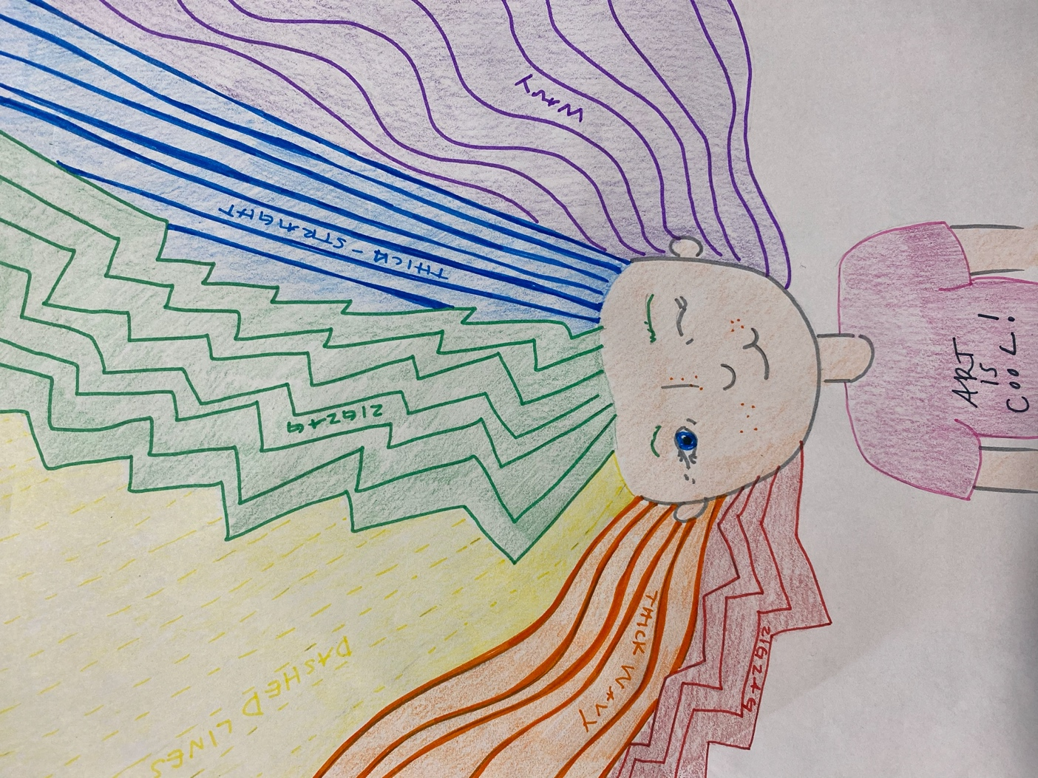

Project: Perspective Name
Overview: Today, we are going to talk a little bit more on perspective. We will start by writing out names, spaced out in all capital letters. From there we will bubble around those letters to make our name into block letters. We will create a vanishing point (a point where all the 3D lines with meet) and draw back lines from the points of our letters to look like it is receding into space. Once your have your lines you can ‘cut off’ where you want your letters to end and color/finish as you please.

Supplies
- Paper
- Pencil
- Eraser
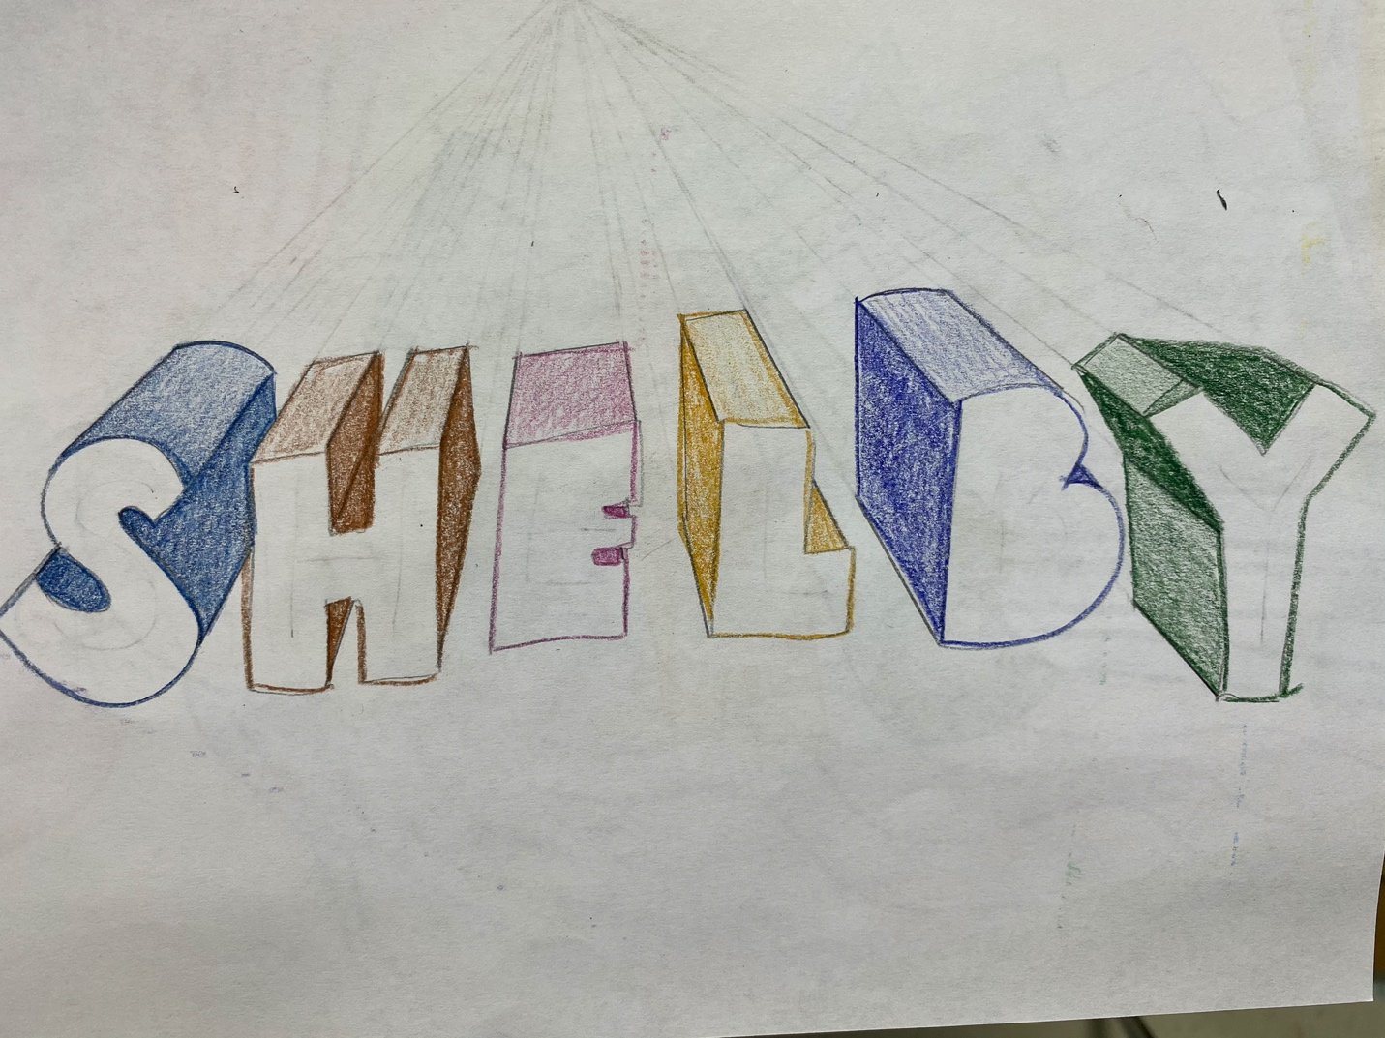
- *Optional something to color with (markers, colored pencils, crayons, etc.)

