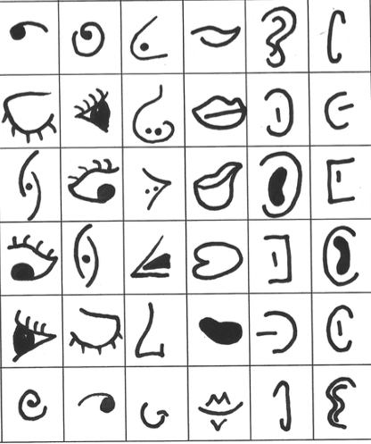
Project: Picasso Portraits
Overview: Today, we are going to create random folds in our paper and use them as guidelines for a Picasso-esque portrait. To the left there is a sheet full of possible features you can use to create your own unique portrait!

Supplies:
- Paper
- Pencil
- Something to color with (crayons, markers, colored pencils)
- Eraser
- Facial Feature Inspiration

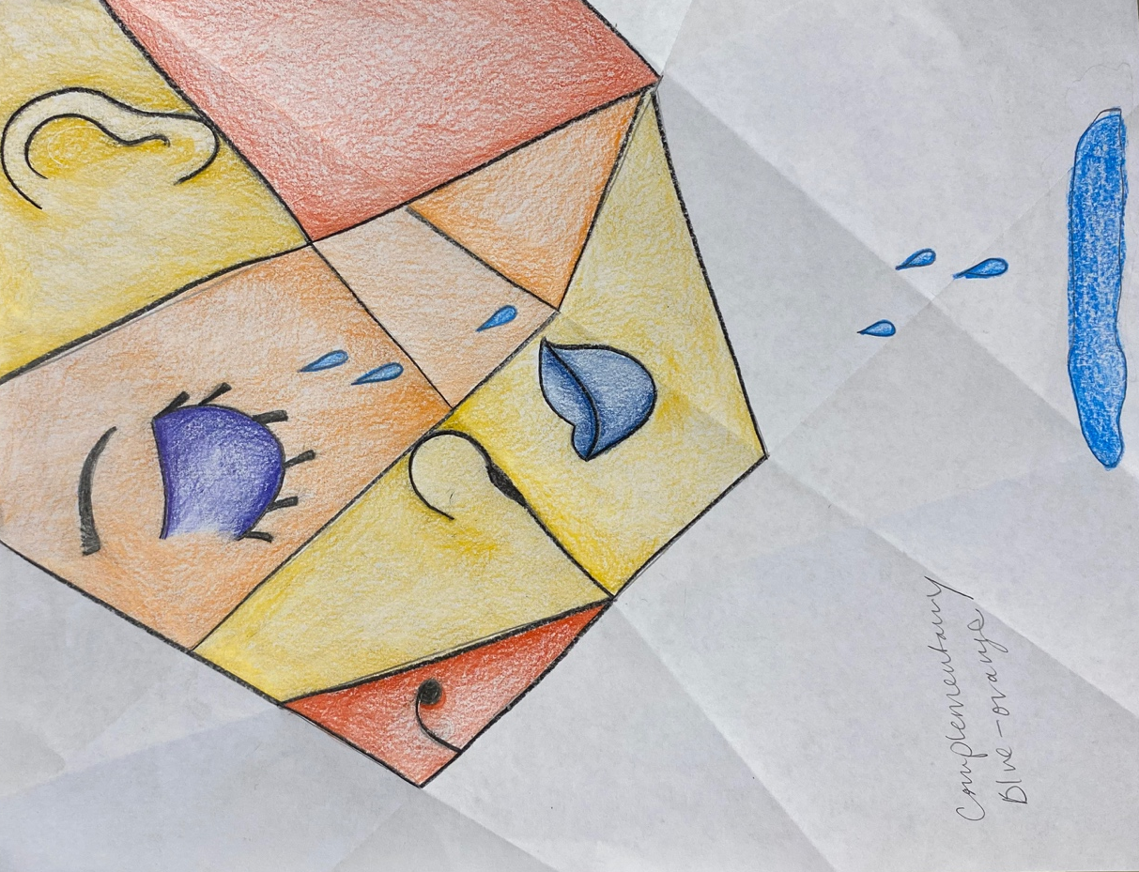

Project: Blind Contour Color Schemes
Overview: Today, we are going to learn about blind contours. A contour line is a drawing of the outline of an object (kind of like a coloring sheet). We are going to do this blind, meaning we are not going to look at out papers as we draw. I will be completing a contour drawing of my hand, but feel free to use any object or even yourself! We will then pick a color scheme (primary, secondary, warm/cool or analogous, etc.) to color in the shapes. Keep in mind this is meant to be rather abstract.

Supplies
- Paper
- Pencil
- Eraser
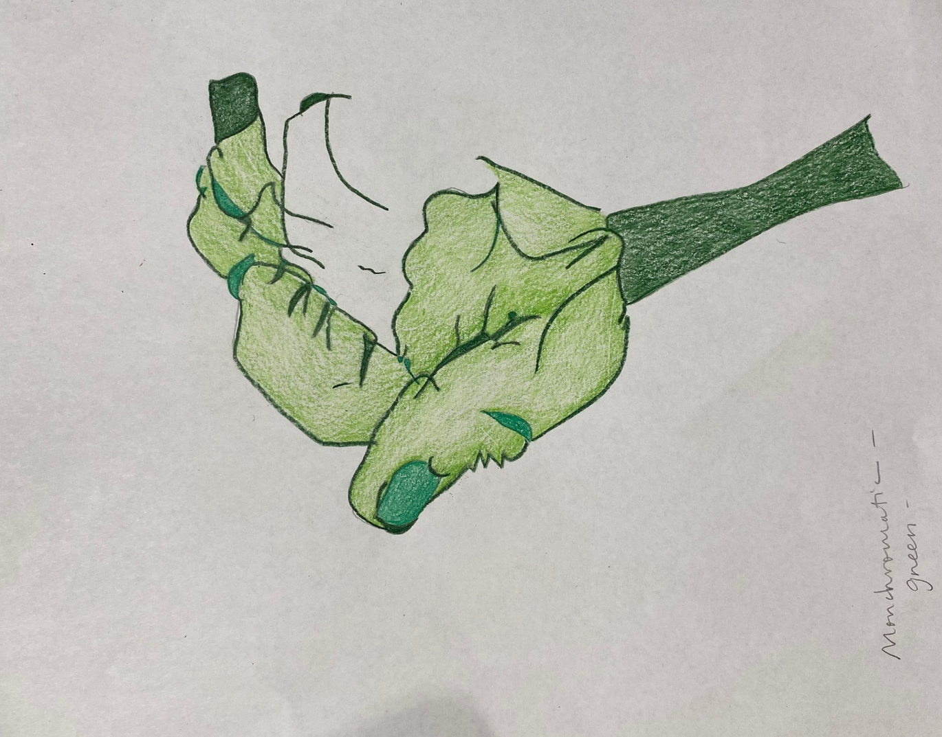
- Something to color with (colored pencils, crayons, market, etc.)

