Project: How to Draw and Owl
Overview: Today I am giving step by step instructions on how to draw an owl. From there, we are going to color and design your owl how you please. Once you are finished, cut him/her out and glue onto black paper.

Supplies:
- Paper
- Pencil
- Eraser
- Something to color with (markers, crayons, colored pencils)
- Black paper
- Scissors
- Glue

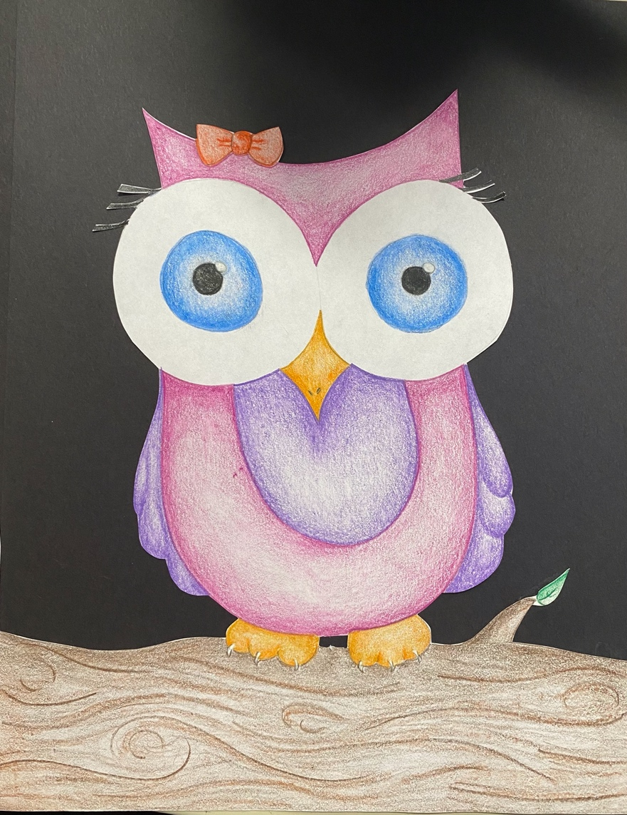

Project: Shading a Ball/Sphere
Overview: Today we are going to shade a sphere. I used colored pencils in the video because they don’t smear. However, if you’d prefer a pencil, make sure not to rub your hand across or the graphite will smear. We also talked about the cast shadow created.

Supplies
- Pencil or Colored Pencil (not yellow)
- Eraser
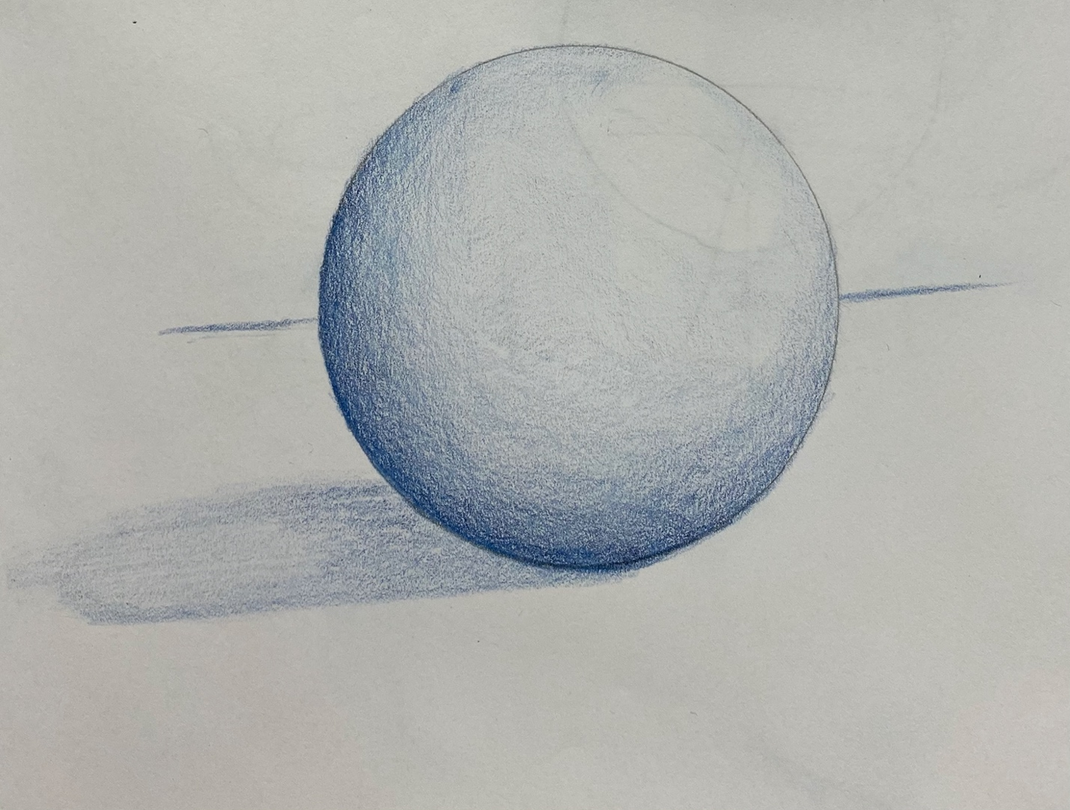
- Paper

