Project: Growing a Rainbow
Overview: Today we are going to start by preparing out workstation, you need to have two small cups of water, about half full. Cut your paper towel down to about 2 by 6 inches. Next, color both ends of the paper towel in the order of the rainbow (red, orange, yellow, green, blue and purple). When you fold in half the colors should match up. Next, put the ends in each cup of water and watch the magic! (p.s. the water should pull the colors and blend them together to create your own rainbow.)

Supplies:
- 2 small cups of water
- Paper towel (cut into small strip)
- Markers (red, orange, yellow, green, blue and purple)
- Scissors

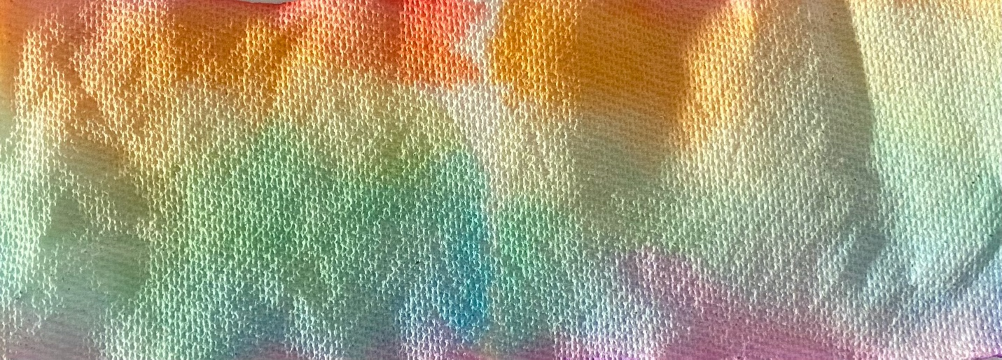

Project: Heart Stippling
Overview: Today we are going to learn about drawing and cutting out a symmetrical heart. Once done, we will talk about the difference between stippling and pointillism and fill in the heart with valentine’s day colors!

Supplies
- Paper
- Pencil
- Eraser
- Markers
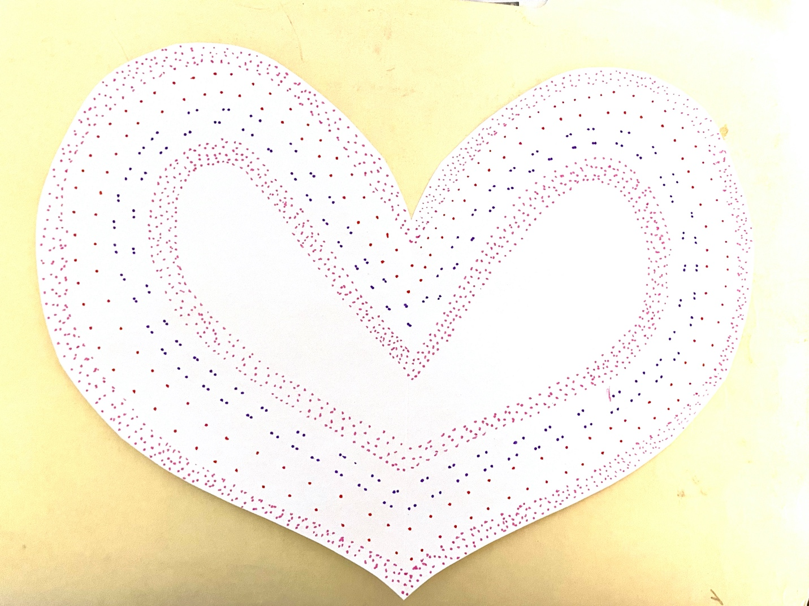
- Scissors

