Project: How to Draw: Bubble Letters/Numbers
Overview: Today we are on a step-by-step process of how to make nice bubble letters/numbers. I wanted to do a project that reflects on the last year (or predicts the new year) and showed how to do bubble numbers of 2020! We will start with the regular numbers and draw their outlines, erasing the inside pieces as we go. From there decorate with things related to 2020, whether it be pattern, illustrations or just color! Have fun and Happy New Year!

Supplies:
- Paper
- Pencil
- Eraser
- Something to color with (markers, crayons, colored pencils)

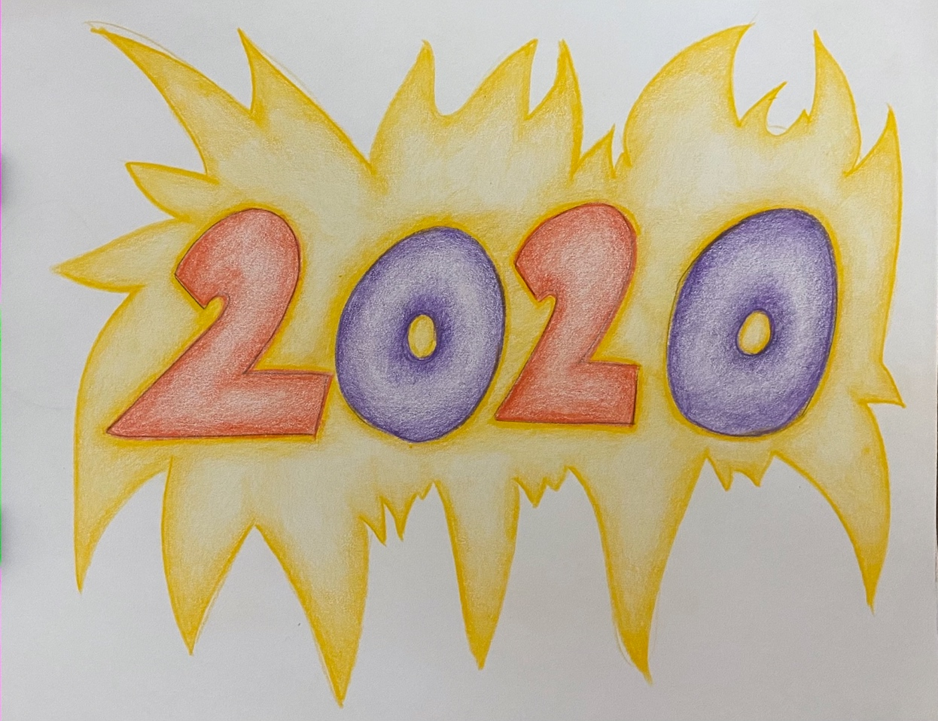

Project: Tinfoil Doodles and Color Theory
Overview: Today we are going to talk a little bit about color for our tinfoil doodles prompt. We will begin with some tinfoil, whatever you use to wrap leftovers in is fine! From there we are going to think about what colors you want to use. We talked about a couple different color schemes. Primary (red, blue and yellow), Secondary (purple, green and orange) and complementary color pairs (red:green, blue:orange, and yellow:purple). Make your choice and get to doodling!

Supplies
- Sharpie Makers (colored or just black)
- Eraser
- Tinfoil

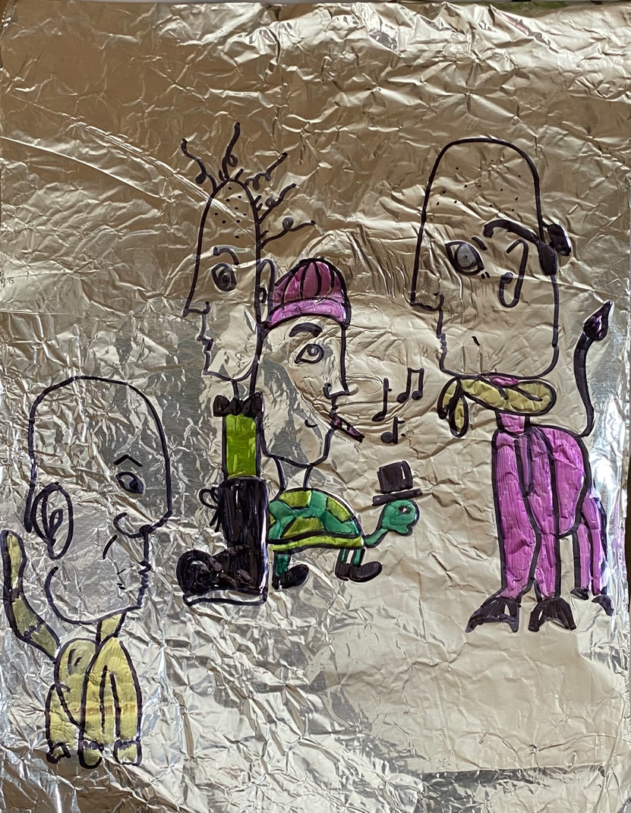

Project: Paper Weaving
Overview: Today we are working on paper weaving. I will start by drawing lines where I am going to cut strips out of one of the pieces of paper, it doesn’t matter how many you make, however the skinnier the strips, the longer the project will take you. Also pay attention to the length of the strips, if you are making short ones, make sure that the other piece of paper is opposite so they weave together. From there we will fold the other piece of paper and cut some strips there, making sure not to cut all the way through, this will act as our loom and we want it to stay in one piece. From there we will alternate between colors and weave the paper together. Once you are finished, you may tape together and add pattern or color if you choose.

Supplies:
- Paper (2 pieces- colored of plain)
- Pencil
- Eraser
- Scissors
- Something to color with (markers, crayons, colored pencils)
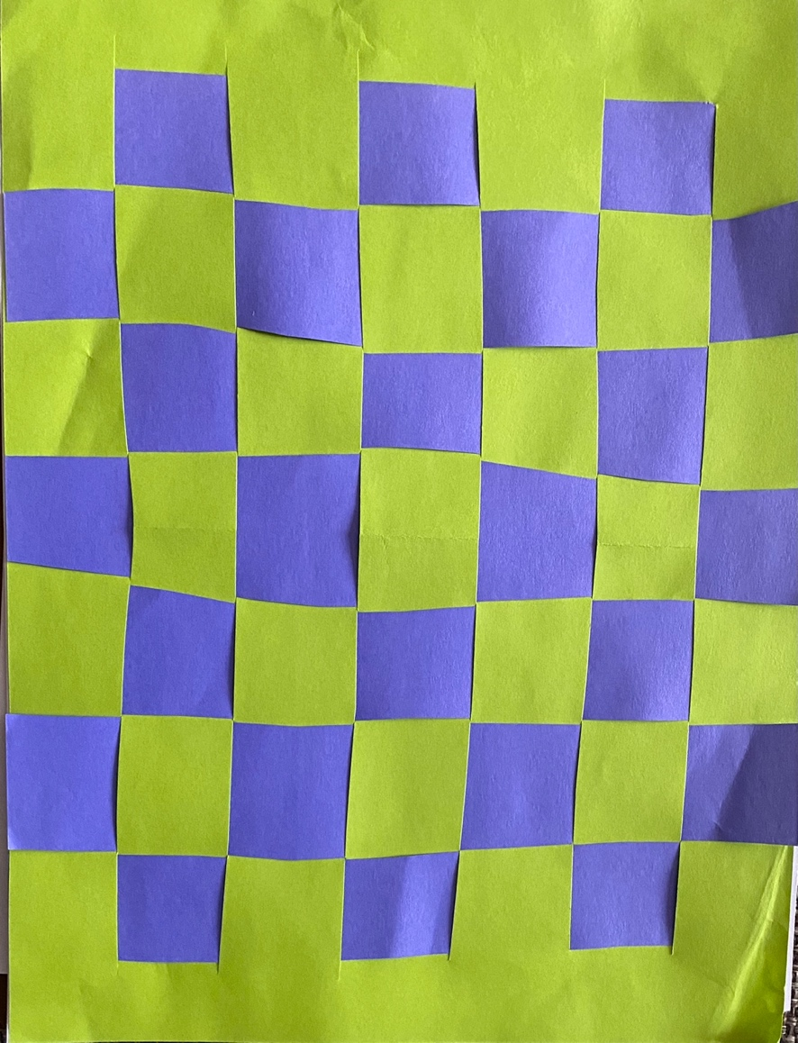
- Tape

