Project: Marker Stippling
Overview: Today we are working the difference between stippling and pointillism. Then we are going to draw something, I drew a Christmas tree, but you’re more than welcome to use whatever you choose. From there we are going to fill in the space with stippling, small dots that from a distance fill the space and show form and color.

Supplies:
- Paper
- Pencil
- Eraser
- Markers (thick of thin)

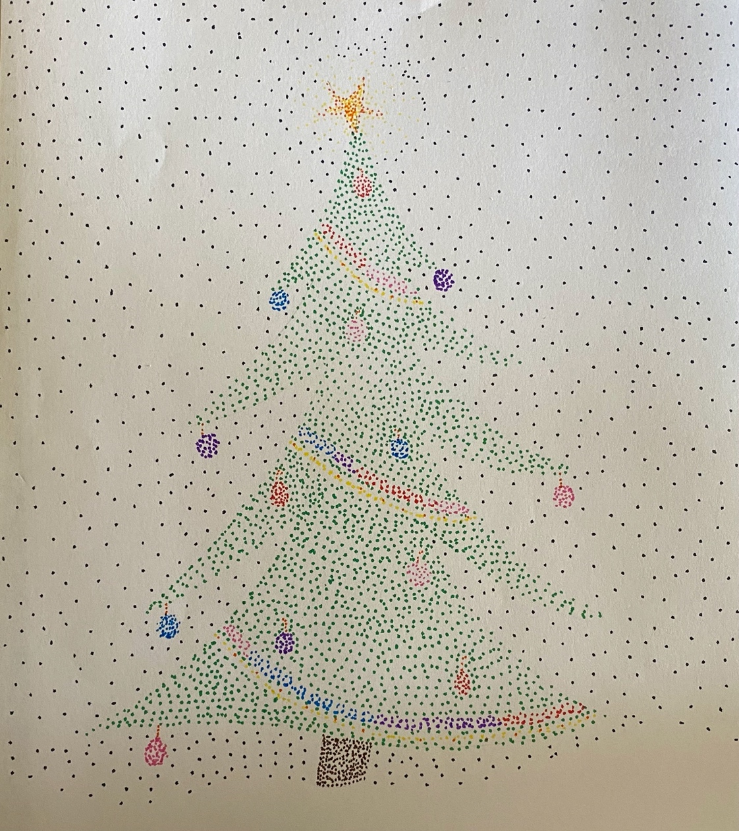

Project: Warm/Cool Robots
Overview: Today we are going to start by talking about shapes and color. For this project, I would like you to draw a robot using at least 1 square, 1 circle and 1 triangle. Then color in the buttons with warm colors (red, orange, yellow and pink) and the body of the robot with cool colors (blue, purple or green).

Supplies
- Pencil
- Eraser
- Paper
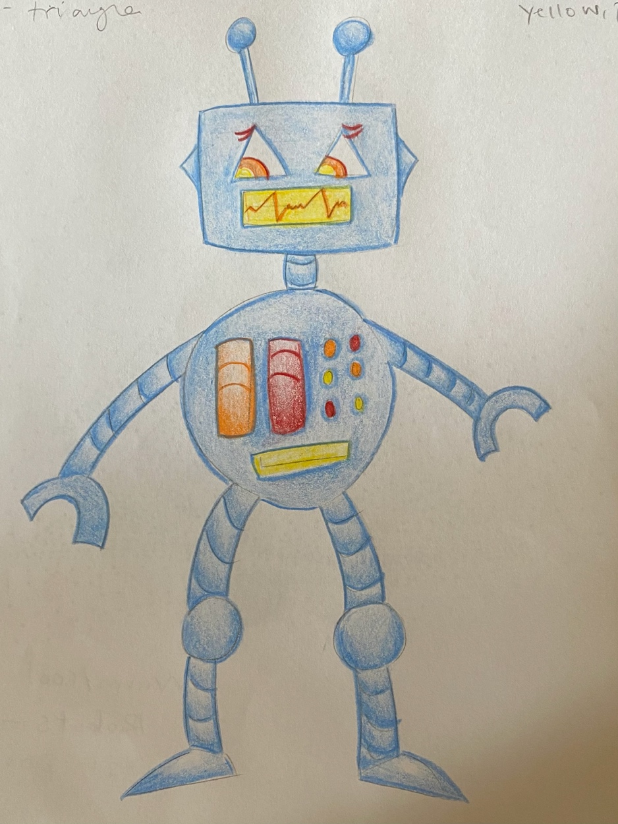
- Something to color with (markers, crayons, colored pencils, etc.)

