Project: Cool/Warm Colored Hands
Overview: Today, we are going to learn about the difference between cool and warm colors! We will practice hand eye coordination by tracing our hand and filling it with either warm or cool colors.

Supplies:
- Paper
- Pencil
- Ruler (optional)
- Something to color with! (colored pencils, crayons, markers)
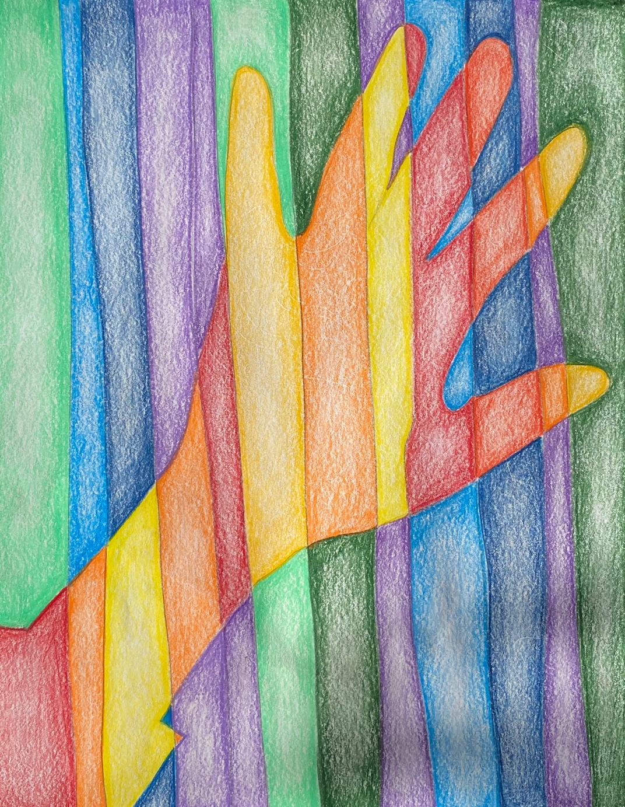

Project: Op Art Squares
Overview: Today, we are going to start talking about optical illusions. To begin we will create the illusion, learning about convex and concave lines and then filling it in using shading to create an optical illusion

Supplies
- Paper
- Pencil
- Straight edge
- Sticky note pad (optional)
- Crayons or colored pencils recommended

