2
Project: Positive/Negative Space
Overview: Today, we are going to talk about positive and negative space in art. Positive space is the subject of the art and the negative space is the blank space around it. We will begin by folding our paper in half and tracing our hand on the fold. We will then trace our hand drawing in colored marker and finish the tracing on the other half of the paper. We will then pick patterns we think are interesting (use your imagination!) and fill in the negative space on 1/2 and the positive space on the other 1/2.

Supplies:
- Paper
- Pencil
- Markers
- A simple object to trace (leaves, your hand, a lid, etc.)
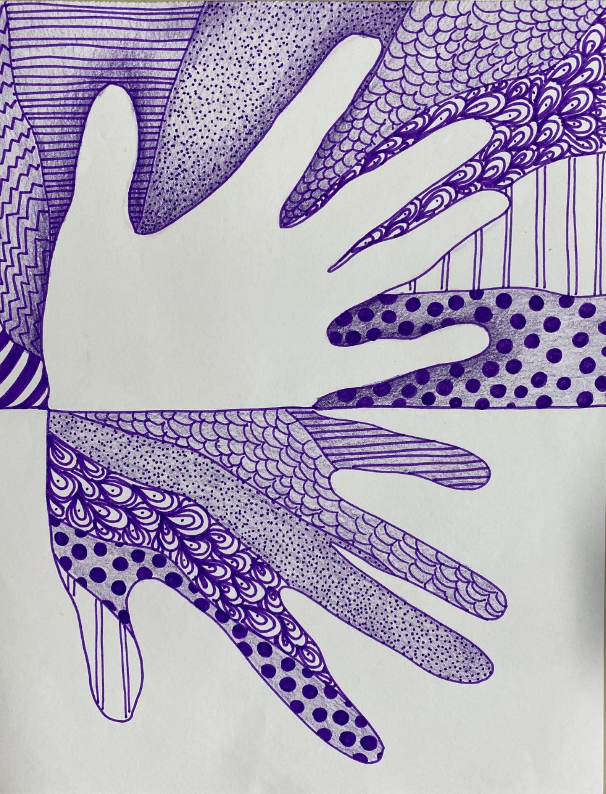

Project: Abstract Alphabet
Overview: Today, we are going to talk about pattern. A pattern is anything that repeats itself more than once. For instance, a line of polka dots is a pattern, or stripes. First, we are going to write out the entire alphabet randomly on a piece of paper, making sure to write in different directions and even overlapping letters. Next, we are going to use pattern and color to fill in some of the spaces the letters create.

Supplies
- Paper
- Pencil
- Eraser
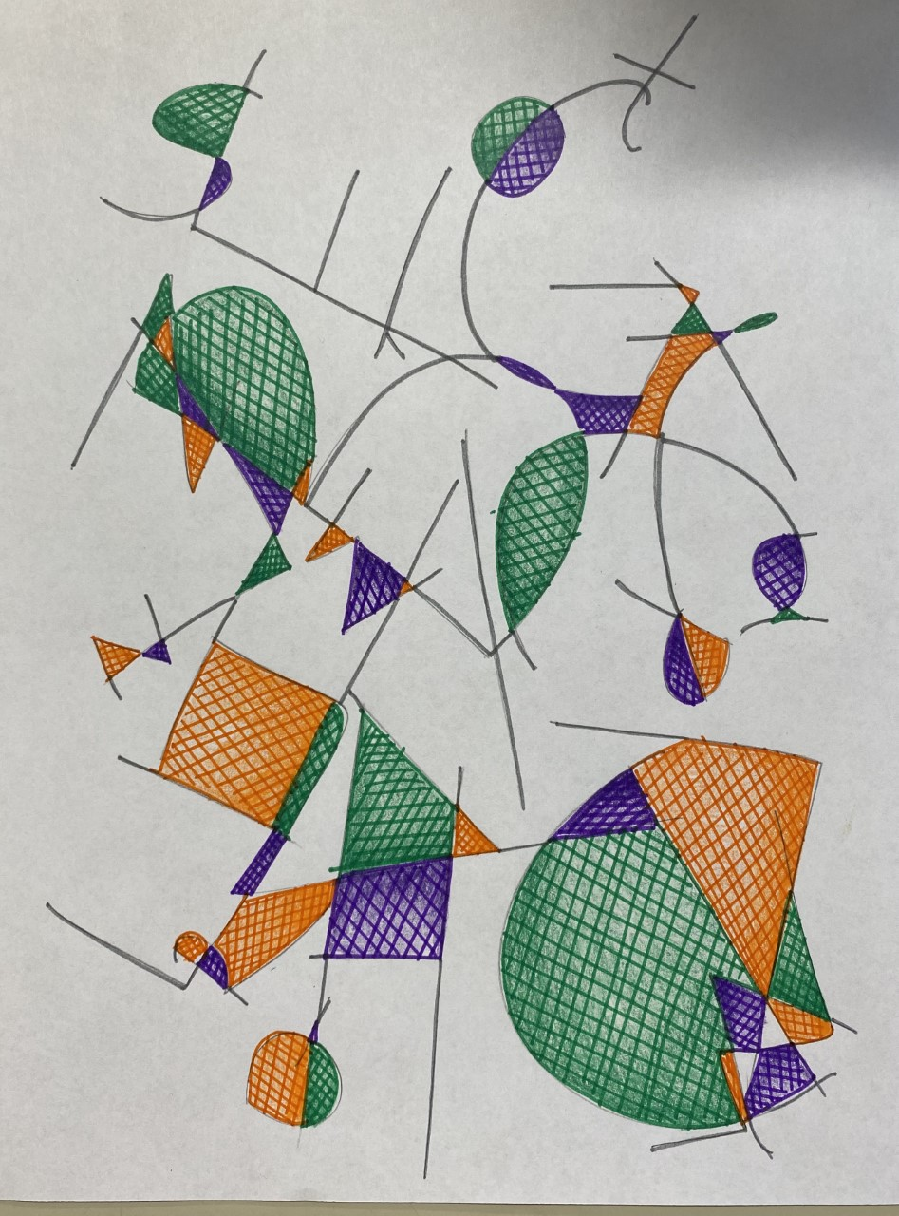
- Something to color with (markers, colored pencils, crayons, etc.)

