Project: Thanksgiving Turkey
Overview: For Thanksgiving this week I am giving step by step instructions on how to draw an turkey. From there, we are going to color and design turkey with whatever colors they want. Once you are finished, cut it out and glue onto black paper.

Supplies:
- Paper
- Pencil
- Eraser
- Something to color with (markers, crayons, colored pencils)
- Black paper (optional)
- Scissors
- Glue
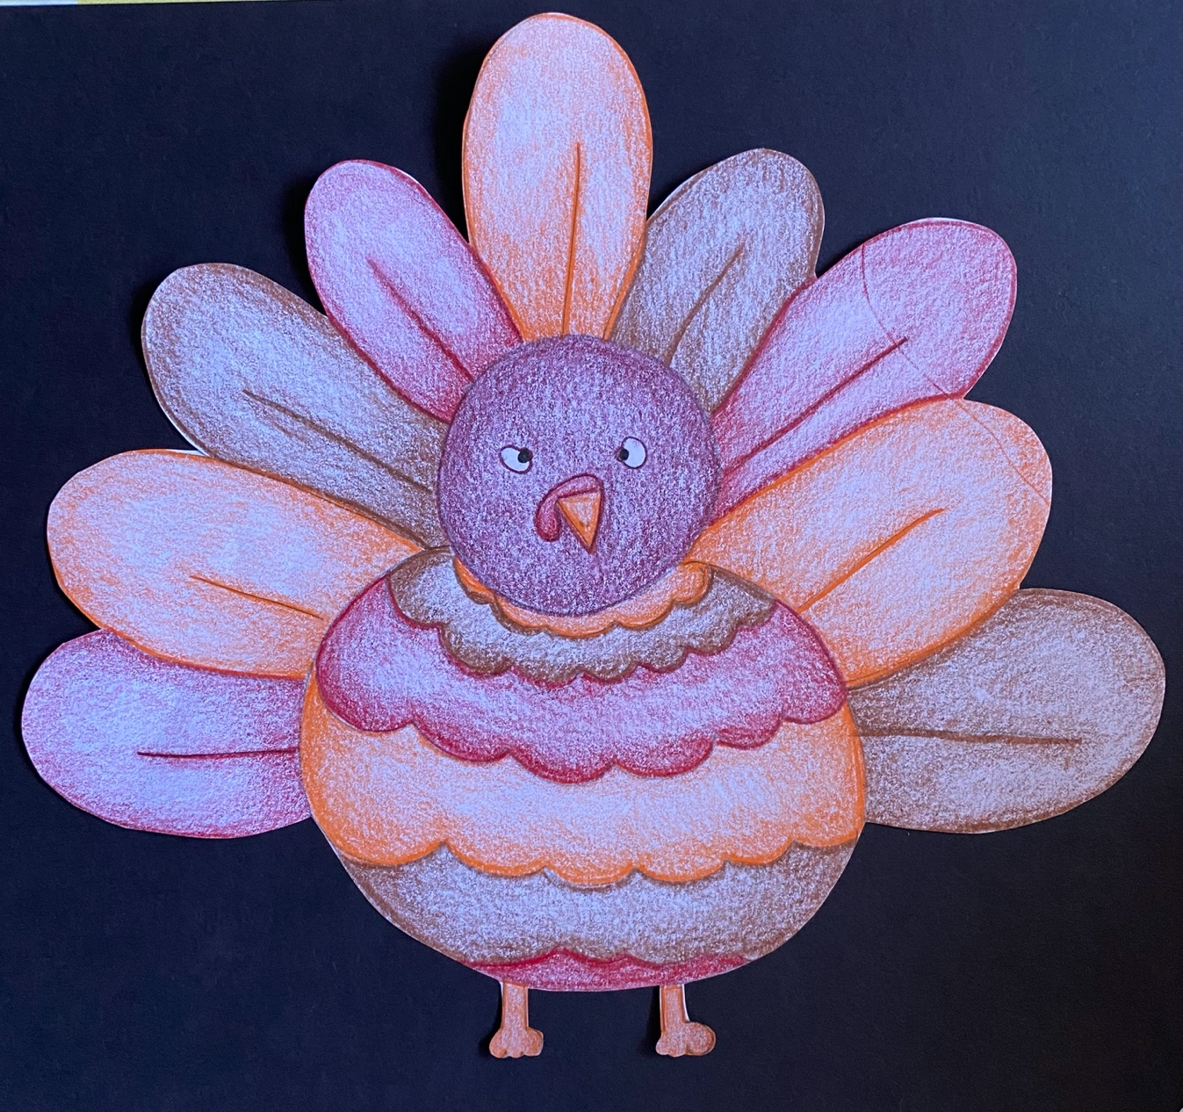
Project: Blending Fall Leaves
Overview: Today we are going to talk about blending colors using either colored pencils or crayons. We will start by talking about different types of leaves and how to draw two different varieties, then moving into how to blend colors together.

Supplies
- Pencil
- Eraser
- Paper
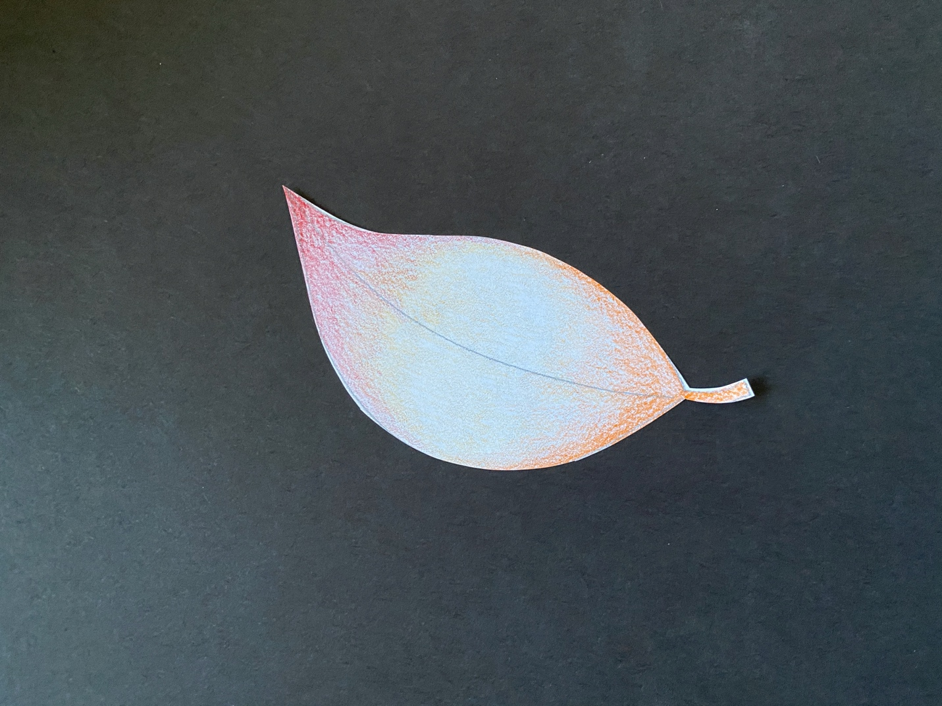
- Something to color with (colored pencils or crayons recommended)
- Black paper
- Scissors
- Glue

